**Informatica Branching Strategy**

**Informatica Branching Strategies**

We have 3 options that are available for us, which are explained below.

1. Migrating from INT1 ----> INT2

* CI Pipeline Exports the informatica Assets from INT1 makes it into an artifact.
* CD pipeline will take the artifact make necessary changes to Variables/Parameters required for INT2 and Export it to INT2

**Con -** Not a best practice for long term

1. Migrating from INT1 ----> INT2

* CI Pipeline Exports the informatica Assets from INT1 and then commits it to INT1 branch, makes it into an artifact.
* CD pipeline will take the artifact make necessary changes to Variables/Parameters required for INT2 and Commits it to INT2 Branch (with changed Variables/Parameters), then it will be Imports it to INT2.

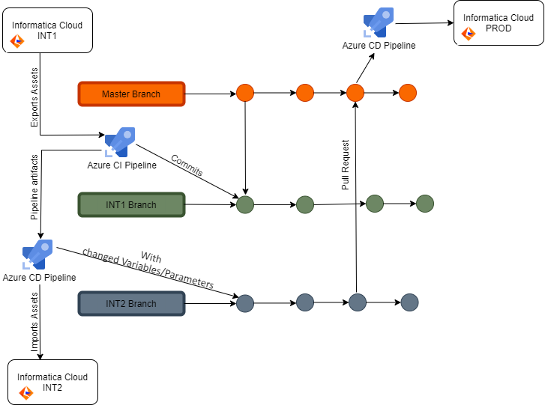

**Con**- It may Require to manually trigger the pipeline. (Need to do some research)

1. Migrating from INT1 ----> INT2

**Pre-Requisite**----source control license needs to be enabled in informatica.

* Informatica developer make enhancement/Changes to the assets in INT1 and check-in the new code to INT1 Branch through informatica
* CI pipeline takes the new code from INT1 Branch makes it into an artifact.
* CD pipeline will take the artifact make necessary changes to Variables/Parameters required for INT2 and Commits it to INT2 Branch (with changed Variables/Parameters), then it will be Imports it to INT2.

As a Best Practice we will be following option no3 and move forward with Informatica Integration and we will also apply branching polices to make it more secure.